AMMAN ARAB UNIVERSITY
جامعة عمان العربـيــــــة
College of Information Technology


كلية تكنولوجيا المعلومات

Gym

Students:
Muhanad Wael Eid | 202310329
Mohammed Ghassan Al-Natour | 202311192
Fares Hussam Al-Essa | 202310326
Fayiz Mohammad Al-Shawsheen | 202310742

Supervisor:
Dr. Alaa Ali Abu Thawabeh

Amman - Jordan
2025/2026
Table of Contents
1.1. Problem Statement page 3
1.2. Business Case page 4
1.3. Project Scope page 5
1.4. Project Goals page 5
1.5 Project Schedule page 6
2. System Analysis page 7
2.1 Functional Requirements page 7
2.2 Use Case Diagram page 7
3. System Design page 8
3.1 ER-Diagram page8
3.2 User Interface (prototype) page9

1.1Problem Statement

Many gyms today continue to rely on manual, paper based methods to manage their daily operations. These outdated approaches introduce a range of operational and financial challenges that obstructs gym growth, staff productivity, and member satisfaction.

  - Core Operational Challenges

• Manual Membership Tracking
◦ Member records, subscription renewals, and plan assignments are handled on paper or in basic spreadsheets, leading to data loss and inconsistency.

• Inefficient Class Scheduling
◦ Scheduling yoga, Zumba, strength training, and other classes without a digital system causes booking conflicts, overbooking, and poor resource allocation.

• Disorganized Payment Management
◦ Financial transactions between members and the gym lack structured recording, making it difficult to track overdue payments, generate reports, or audit revenue.

• Trainer Coordination Difficulties
◦ Managing trainer assignments, specialties, availability schedules, and salary records manually introduces errors and delays across multiple branches.

• Multi-Branch Data
◦ Operating multiple branches without a centralized system causes data silos, inconsistent service quality, and administrative overhead.

These challenges result in wasted administrative time, increased risk of financial errors, reduced member retention, and an inability to scale gym operations efficiently.

  - Business Case
The Gym Management System provides return on investment by automating and centralizing all key gym operations. The following points is why we need development and deployment of this digital solution:

- Operational Efficiency
- Automating membership registration, payment processing, and class scheduling reduces administrative workload, freeing staff to focus on members.
- Financial Transparency & Revenue Growth
- A structured payment module enables real time financial tracking, reduces missed payments.
- Improved Member Experience
- Members gain seamless access to class enrollment, trainer assignment, and subscription management.
- Scalability Across Branches
- The multi branch architecture allows the gym to expand operations while maintaining centralized data oversight and consistent service delivery.
- Reduced Human Error
- Digital data entry and validation minimize the errors inherent in manual record keeping, improving data integrity across all entities.
- Competitive Advantage
- Modern members expect digital experiences. A robust management system positions the gym ahead of competitors still relying on manual processes.

  - Project Scope

The Gym Management System covers the full lifecycle management of all key gym entities. The scope is defined around six primary modules:

Module | Scope Coverage
Member Management | Registration, personal details, subscription tracking, class enrollment
Membership Plans | Plan definition (name, price, duration), assignment to members
Payment Processing | Transaction recording, payment date, amount
Class Management | Class scheduling, capacity control, trainer assignment, enrollment
Trainer Management | Trainer profiles, specialties, salary, availability
Branch Management | Multi branch support with location details, phone, and staff linkage

  - Project Goals
The Gym Management System is designed to achieve the following operational goals:

- Digitize All Gym Operations
- Replace all manual, paper based processes with a centralized digital system that manages members, trainers, classes, payments, and branches from a single platform.
- Ensure Data Integrity & Consistency
- Enforce unique identifiers and structured data models for every entity, eliminating duplicate records and data fragmentation across branches.
- Streamline Financial Management
- Provide a complete payment tracking module that links each transaction to its member and membership plan, enabling accurate financial reporting.
- Enable Efficient Class & Trainer Coordination
- Allow administrators to schedule classes with defined capacities, assign qualified trainers, and manage trainer availability schedules without conflicts.
- Support Multi Branch Scalability
- Design the system to accommodate an unlimited number of branches, with each branch having independently managed staff, classes, and location details.

1.5 Project Schedule
Here is the Gantt Chart to schedule and manage the Online Shop project.
And how we distribute the tasks of this web project.

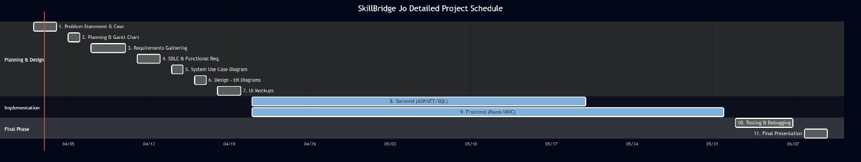

Figure 1: Gantt Chart of Gym System

2. System Analysis

2.1. Functional Requirements
- Member Management: The system shall allow administrators to register new members with unique ID, name, gender, date of birth, phone, and email.
- Class Management: The system shall allow members to enroll in one or more classes with capacity enforcement.
- Payment: The system shall record payments linked to a specific member and membership plan.
- Membership Plans: The system shall allow admins to create and manage membership plans with name, price, and duration.
- Trainer Management: The system shall store trainer profiles including specialty, salary, hire date, and availability.
- Branch Management: The system shall support multiple branches, each with independent staff and class listings.

2.2 Use Case Diagram
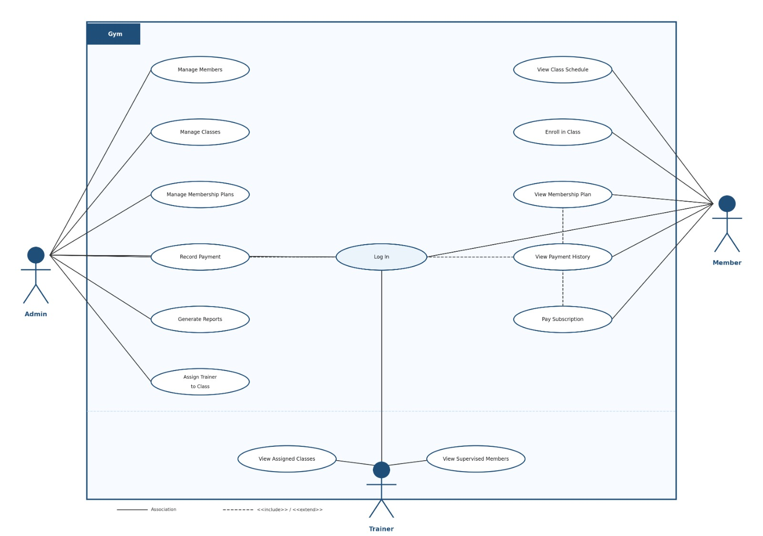

Figure 2: Use Case diagram of Gym system
3. System Design

3.1 ER-Diagram

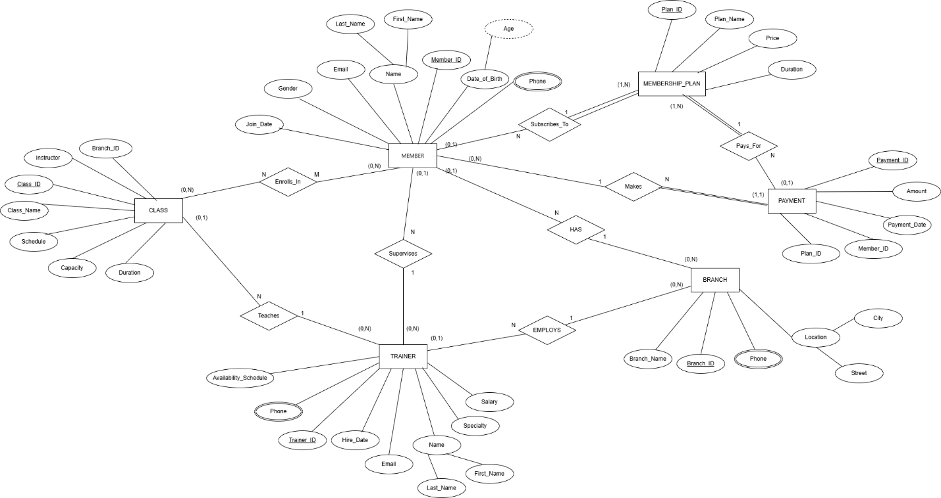

Figure 3: ER diagram Gym System

3.2 User Interface (prototype)

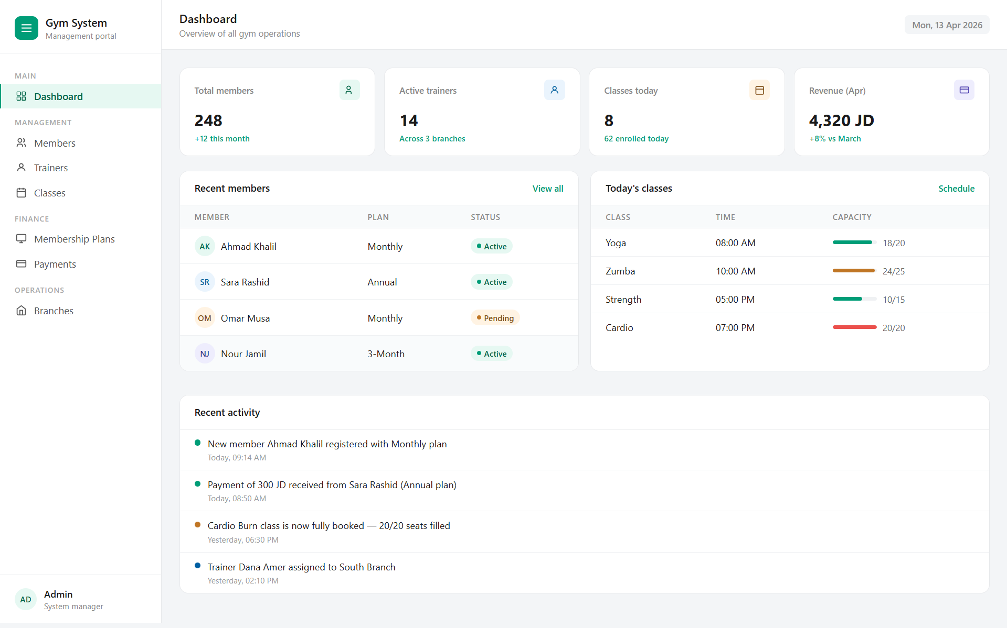

Figure 4: Dashboard Screen (Main Screen) of Gym System

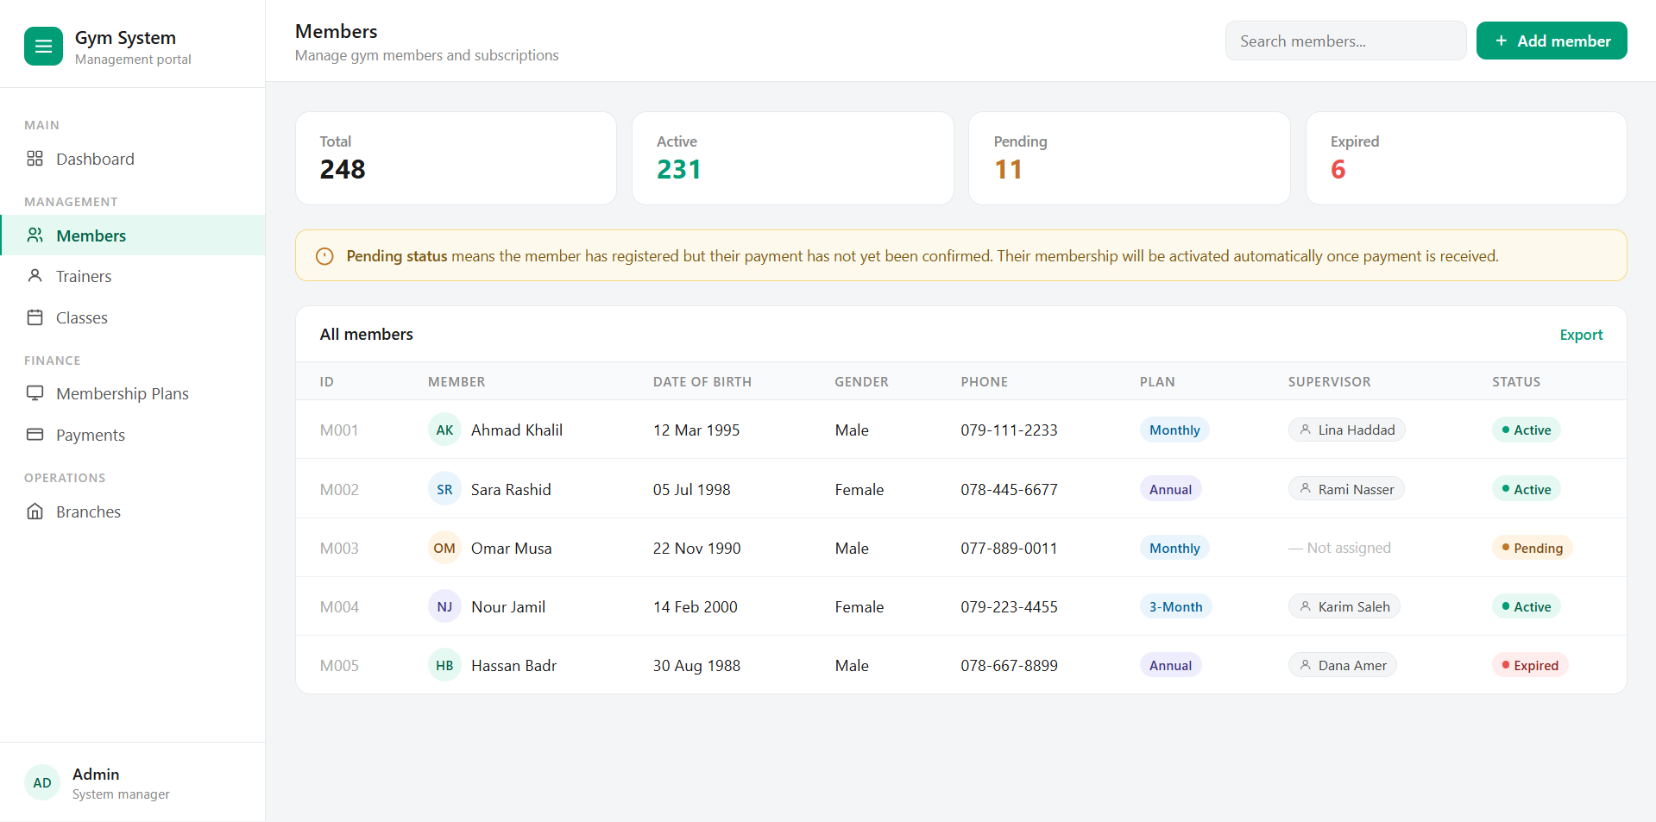
Figure 5: Members Screen of Gym system

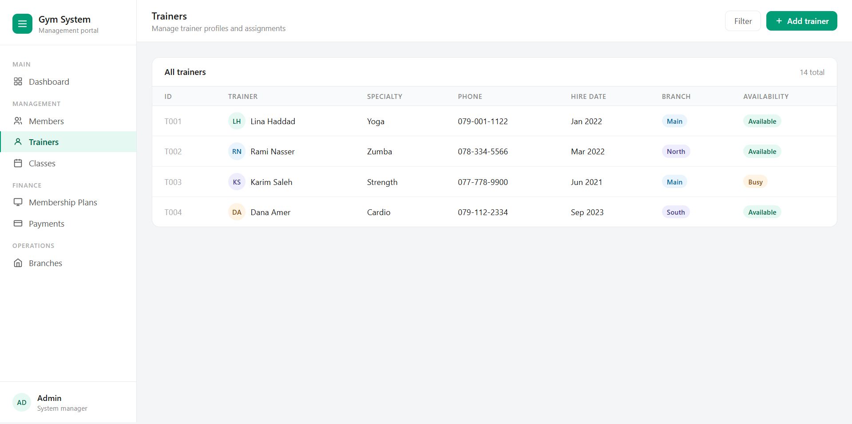

Figure 6: Trainers Screen of Gym system

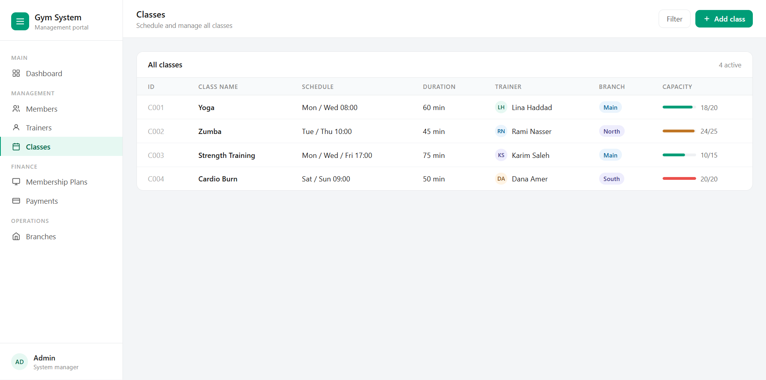
Figure 7: Classes Screen of Gym system

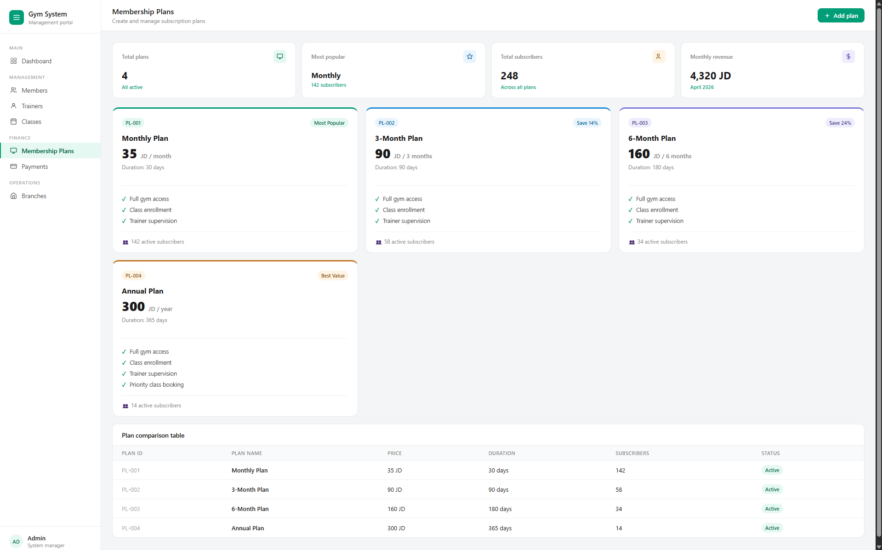

Figure 8: Membership Plans Screen of Gym system

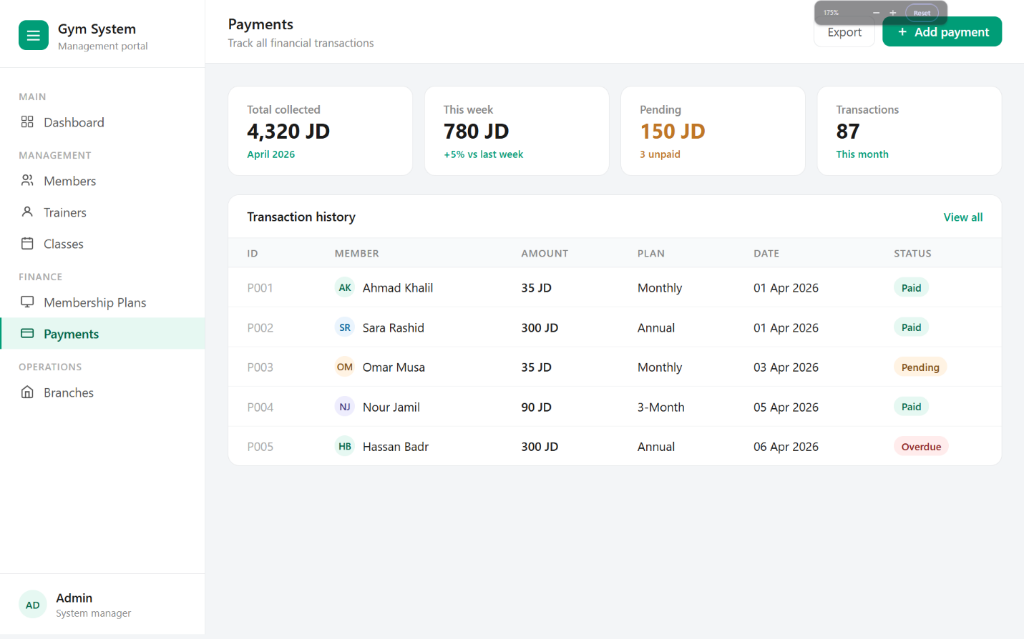
Figure 9: Payment Screen of Gym system

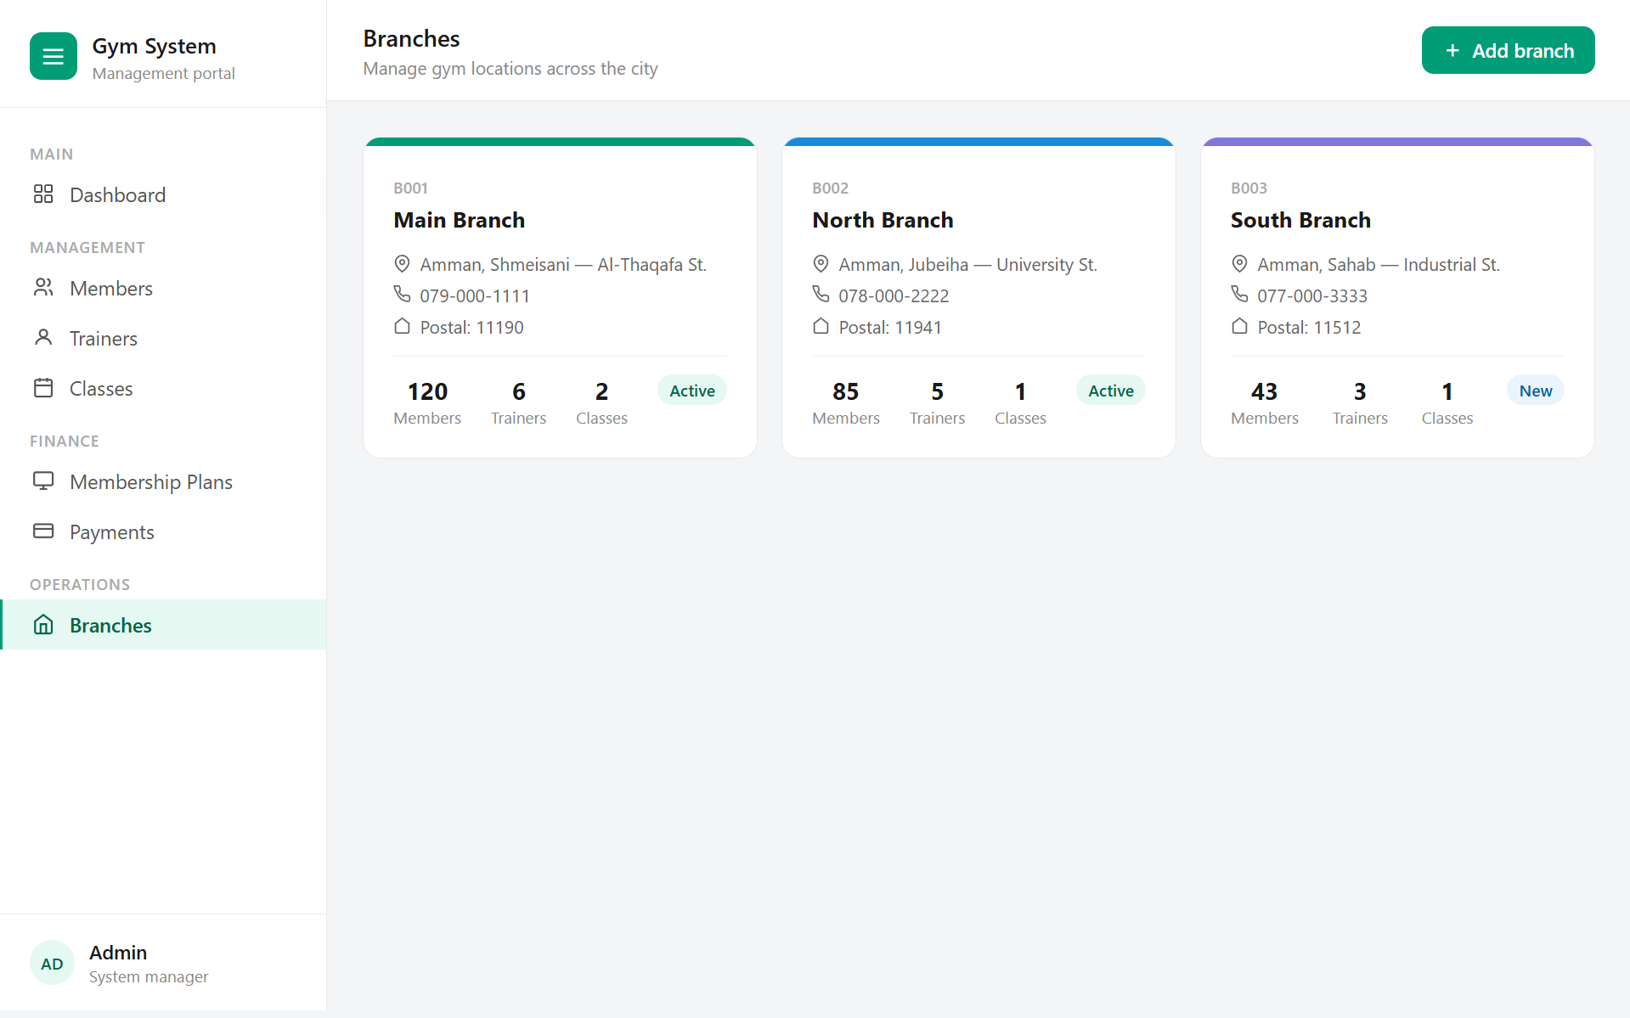
Figure 10: Branches Screen of Gym system

